Blake Dawson
SALT
V4.2

Identified issues with
Lectora Integration

Lectora Integration 3
1.1 Identified issues 3
1.1.1 Launching the quiz separately from the lesson. 3
1.1.2 Is sufficient data available to build a quiz summary? 5
1.1.3 Style sheets will not be incorporated into Lectora lessons. 6
1.1.4 The Quick Fact Sheet may be automatically extracted from the Lectora Lesson so that SALT can launch it separately. 7

Lectora Integration
Content (hereafter referred to as “Lectora Lessons”) produced by the Lectora content authoring system will be incorporated into SALT v4.2.
“Lectora Lessons” may be combined with other “Lectora Lessons” to produce a course however “Lectora Lessons” may not be combined with InfoPath lessons in the same course.

Identified issues

Launching the quiz separately from the lesson.
The current “Lectora Lessons” contain a single SCO that contains the lesson AND quiz.
The smallest launchable object in the SCORM specification is a SCO (Sharable Content Object), therefore (without modification) the quiz cannot be launched independently of the lesson.

Possible solutions:

Change the Lectora Template so that the Lesson and quiz are contained in separate “Lectora Lessons”

Change the Lectora Template so that the lesson and quiz are contained in separate SCOs in a “Lectora Lesson”.

Change the Lectora Template so that the “You have previously been in this lesson, Would you like to return to the last visited location in the lesson” dialog will not be displayed when the SALT API starts the Lesson on the first page of the quiz.

It is possible to launch the SCO and “tell it” that the last page it visited was the first page of the quiz (return a value of “a001_lesson_quiz_first_page.html’ to the initial call of cmi.core.lesson_location) however this dialog would appear
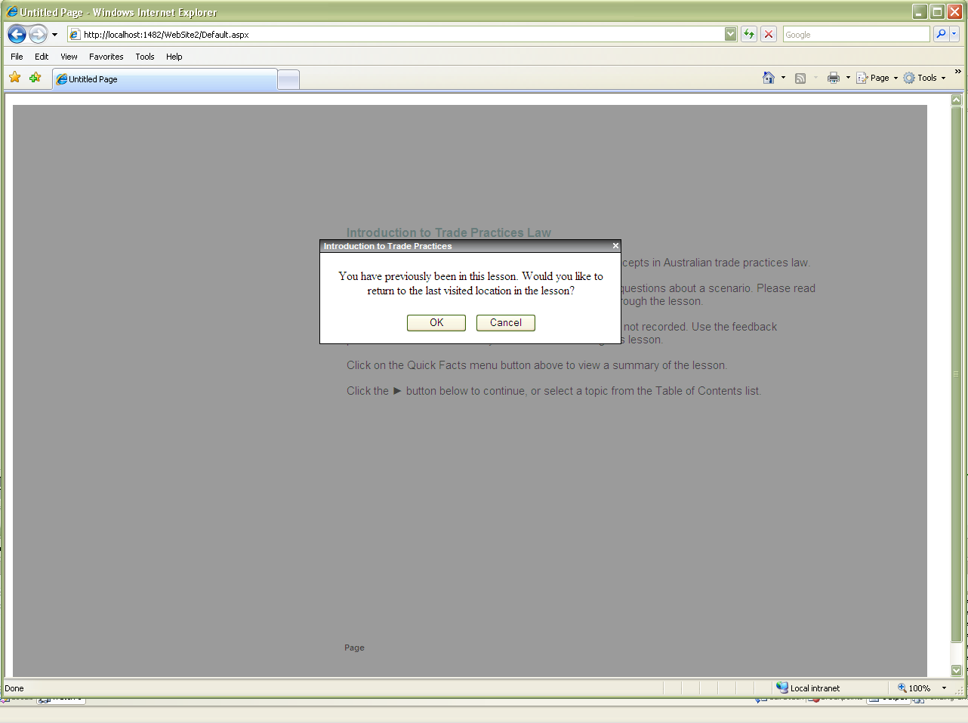
And pressing ‘cancel’ would take you to the start of the lesson so this dialog must be suppressed when starting the quiz.
The SALT API could return a specific answer (say) “quiz” to a get_value reference to the Data Model element “cmi.core.lesson_mode” when the API wishes the “You have previously been in this lesson, Would you like to return to the last visited location in the lesson” dialog to be suppressed.

SALT will automatically upload a slightly modified copy of the Lectora Lesson as the QUIZ (with a slight change to the “redirPage” variable in one of the files (a001titlemgr.html) so that it launches the QUIZ instead of the lesson)

- This method of launching the quiz will go directly to the first page of the quiz.
- It will only work with LECTORA resources. (Not with other SCORM 1.2 resources)
- It may cease to work if BD creates SCORM resources using a new course template.
- It may cease to work with the existing course template if it is used with a different version of LECTORA.

Is sufficient data available to build a quiz summary?

The current Lectora template ONLY exposes the score for the lesson (plus a few other parameters such as total time for the lesson and the lesson status – incomplete, complete, etc) so it is impossible to build a “Quiz Summary”

The sample lessons do save the overall “score” in the cmi.core.score.raw Data Model element and writes to that element will also be saved in the correct SALT tables (if the user is valid, enabled, authorized , current, etc)
In this way SALT v4.2 can monitor and report on the saved SCORM results using the standard Reports (except for the Quiz Summary) in the same way that SALTv4.2 monitors and reports on scores from InfoPath lessons.
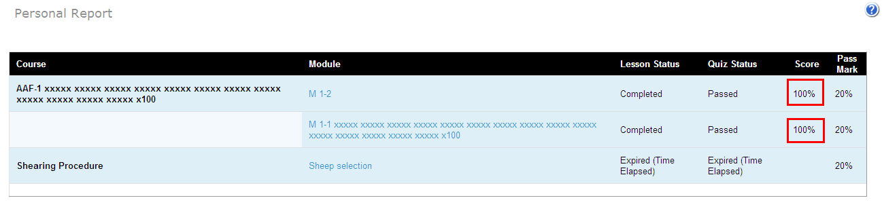)

Possible solutions:

The Lectora Template could be changed to save the questions, user answers and correct answers to Data Model elements if the Quiz Summary Report is to be generated for “Lectora Lessons”.
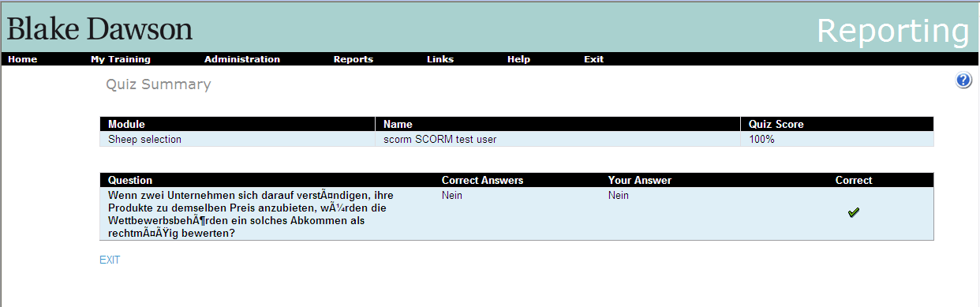

The Lectora Template could be changed to save the user answers and correct answers to Data Model elements if the Quiz Summary Report is to be generated for “Lectora Lessons” and the Question text could be extracted from the assets in the Lector Lesson.
It would be possible to extract the question text from all assets in the “Lectora Lesson” whose name begins with “A001_quiz” however this method would require no changes to the naming conventions and layout of quizzes in the Lectora Lessons for continued operation,
i.e.
- It will only work with LECTORA resources. (Not with other SCORM 1.2 resources)
- It may cease to work if BD creates SCORM resources using a new course template.
- It may cease to work with the existing course template if it is used with a different version of LECTORA.

The Quiz Summary Report could be suppressed for “Lectora Lessons”.

Style sheets will not be incorporated into Lectora lessons.
SALT Style Sheets (such as Clifford Chance) will not affect Lectora Content?
i.e. the existing Style sheets will not work with Lectora Content.
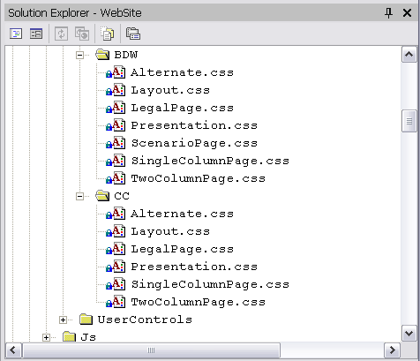

The Quick Fact Sheet may be automatically extracted from the Lectora Lesson so that SALT can launch it separately.

There is no method to extract the Quick Fact Sheet from a SCORM resource under the SCORM 1.2 standard, however the existing SALT Lectora Template provides a link to the Quick Fact Sheet so it is possible to extract the Quick Fact Sheet from Lectora Lessons prepared using the existing Template.

Note :
- It will only work with LECTORA resources. (Not with other SCORM 1.2 resources)
- It may cease to work if BD creates SCORM resources using a new course template.
- It may cease to work with the existing course template if it is used with a different version of LECTORA.
